Test 1

1.Even or Odd

Program:

#include <stdio.h>

int main() {

int num;

printf("Enter an integer: ");

scanf("%d", &num);

if(num % 2 == 0)

printf("%d is even.", num);

else

printf("%d is odd.", num);

return 0;

}

Output:

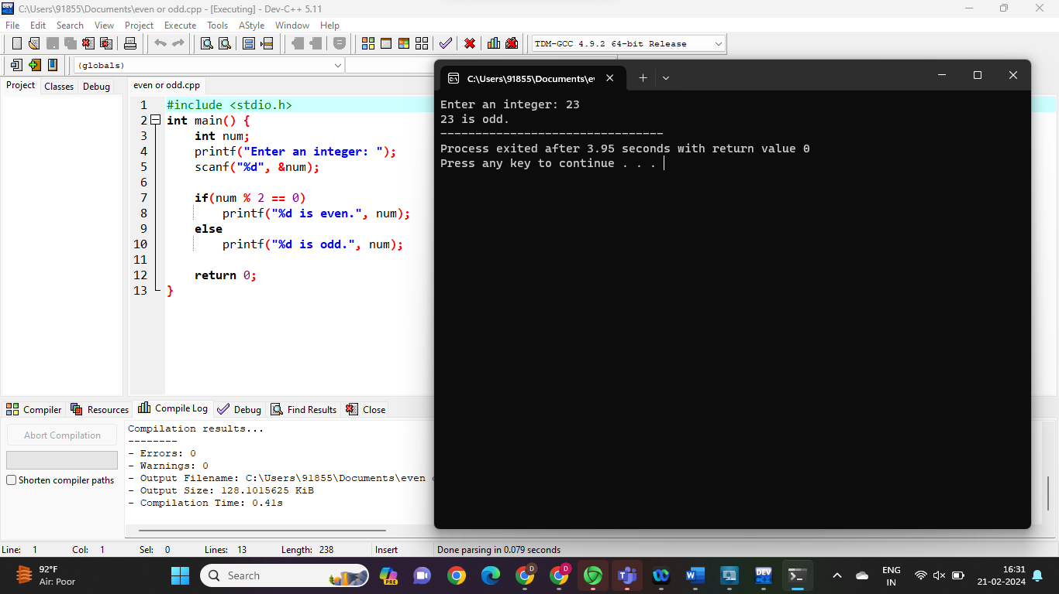

2.Sum of even and odd numbers

Program:

#include <stdio.h>

int main()

{

int i, num, odd_sum = 0, even_sum = 0;

printf("Enter the value of num\n");

scanf("%d", &num);

for (i = 1; i <= num; i++)

{

if (i % 2 == 0)

even_sum = even_sum + i;

else

odd_sum = odd_sum + i;

}

printf("Sum of all odd numbers = %d\n", odd_sum);

printf("Sum of all even numbers = %d\n", even_sum);

}

Output:

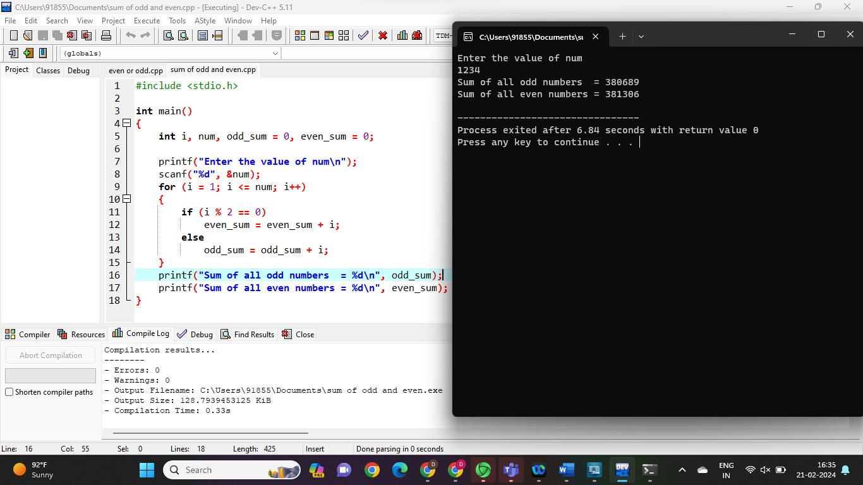

3.POSITIVE OR NEGATIVE

Program;

#include <stdio.h>

int main() {

double num;

printf("Enter a number: ");

scanf("%lf", &num);

if (num <= 0.0) {

if (num == 0.0)

printf("You entered 0.");

else

printf("You entered a negative number.");

}

else

printf("You entered a positive number.");

return 0;

}

Output:

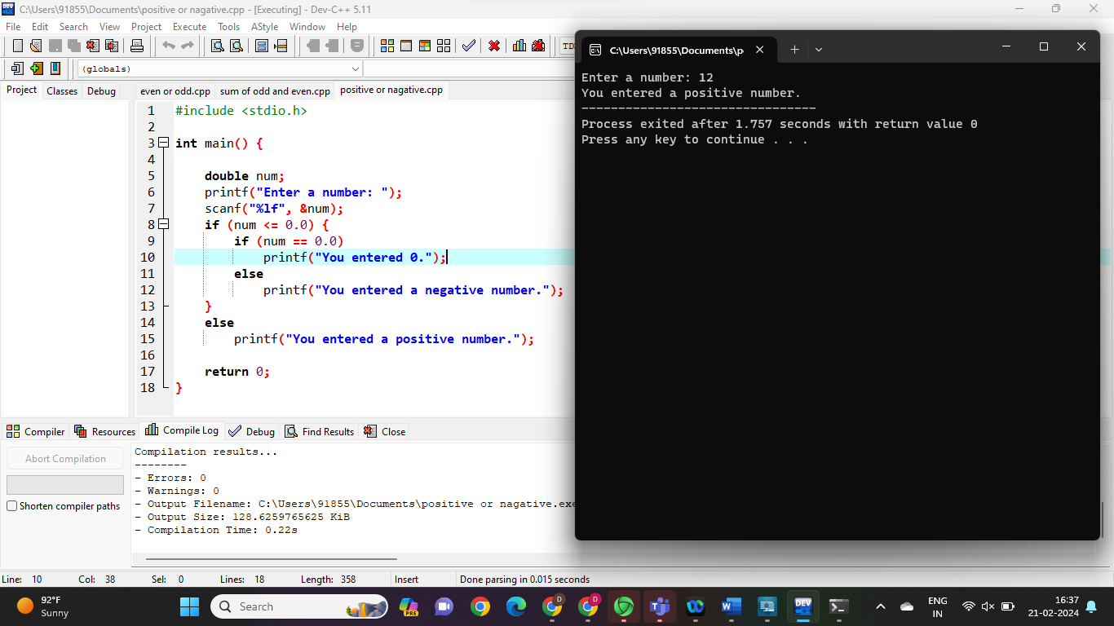

4.Largest among three numbers

Program:

#include <stdio.h>

int main() {

double n1, n2, n3;

printf("Enter three different numbers: ");

scanf("%lf %lf %lf", &n1, &n2, &n3);

if (n1 >= n2 && n1 >= n3)

printf("%.2f is the largest number.", n1);

if (n2 >= n1 && n2 >= n3)

printf("%.2f is the largest number.", n2);

if (n3 >= n1 && n3 >= n2)

printf("%.2f is the largest number.", n3);

return 0;

}

Output:

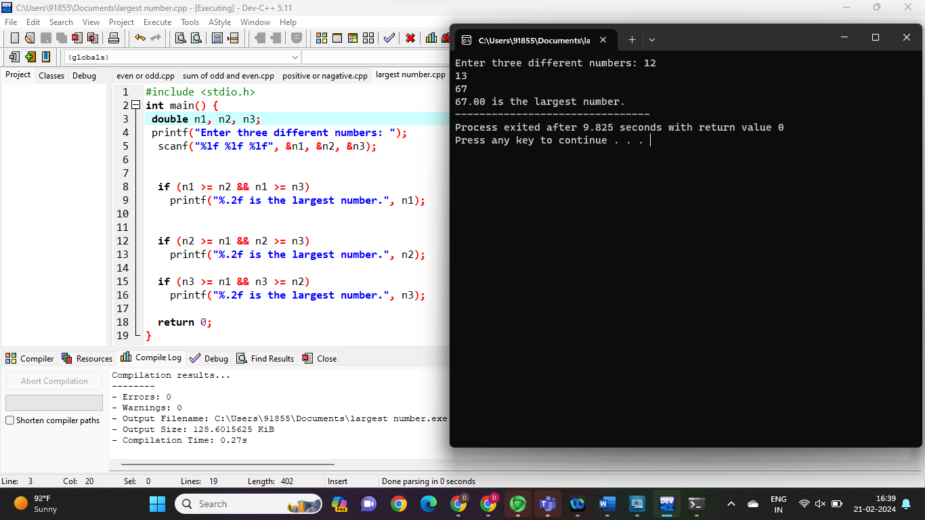

5.Swapping two numbers

Program:

#include<stdio.h>

int main() {

double first, second, temp;

printf("Enter first number: ");

scanf("%lf", &first);

printf("Enter second number: ");

scanf("%lf", &second);

temp = first;

first = second;

second = temp;

printf("\nAfter swapping, first number = %.2lf\n", first);

printf("After swapping, second number = %.2lf", second);

return 0;

}

Output:

